Suppose you want to send a file of size 255,000 over a 2 Mbps link using TCP.

The maximum segment size (MSS), which represents the size of TCP payload, is 1,000 bytes. Two-

way propagation delay between the source and the destination is 10 [msec] . TCP Threshold = 130

packets.

How long will it take to transmit the given file, from the start to the end of TCP transmission?

1st RTT – connection established

2nd RTT – window: 1 MSS => transmitted bytes: 1,000

3rd RTT – window: 2 MSS => transmitted bytes: 1,000 + 2,000 = 3,000

4th RTT – window: 4 MSS => transmitted bytes: 3,000 + 4,000 = 7,000

5th RTT – window: 8 MSS => transmitted bytes: 7,000 + 8,000 = 15,000

6th RTT – window: 16 MSS => transmitted bytes: 15,000 + 15,000 = 31,000

7th RTT – window: 32 MSS => transmitted bytes: 31,000 + 32,000 = 63,000

8th RTT – window: 64 MSS => transmitted bytes: 63,000 + 64,000 = 127,000

9th RTT – window: 128 MSS => transmitted bytes: 127,000 + 128,000 = 255,000

Delay:

9*2-way propagation + (1+2+4+8+16+32+64+128)*packet-transmissions =

= 9*0.01 [sec] + 255*1,020*8 [bits] /2,000,000 [bit/sec] =

= 0.09 + 0.10404 [sec] = 1.13 [sec]

We could possibly add another 1.5 RTT for the (2-way) closing of the connection.

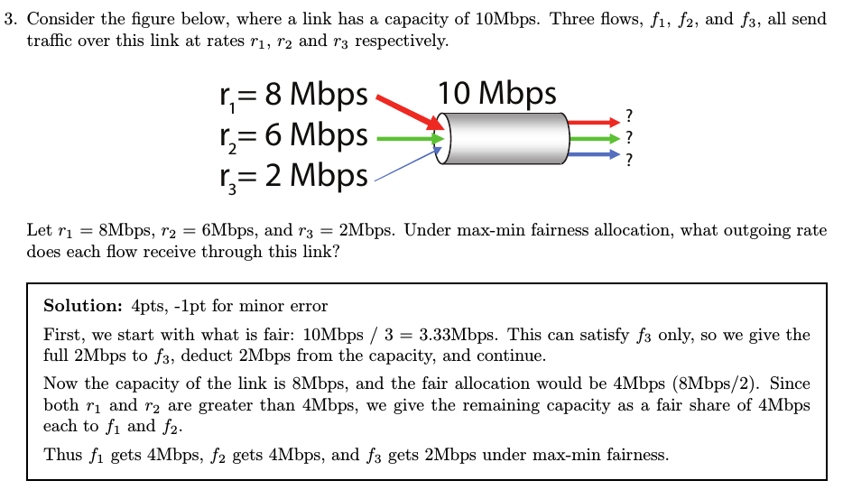

**The diagram at right shows two TCP senders at left and the corresponding receivers at right. The first sender uses TCP Tahoe, the second uses Reno. Assume that the MSS is 1 KB, that the one-way propagation delay for both connections is 50 ms and that the link joining the two**

**routers has a bandwidth of 6 Mb/s. Let cwnd1 and cwnd2 be the values of the senders’ congestion windows.**

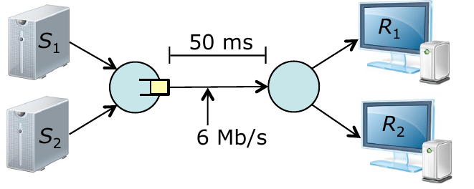

**Assume that the link buffer overflows whenever cwnd1+cwnd 2≥150 KB and that at time 0,**

**cwnd1=30 KB and cwnd2=120 KB. Approximately, what are the values of cwnd1 and cwnd2 one RTT later? Also, what are the values of ssthresh for each of the two connections? Assume that all losses are detected by triple duplicate ACKs.**

*Since the first uses Tahoe and the second uses Reno, cwnd1=1 KB and cwnd2= 60 KB, ssthresh1=15 KB and sshresh2= 60 KB.*